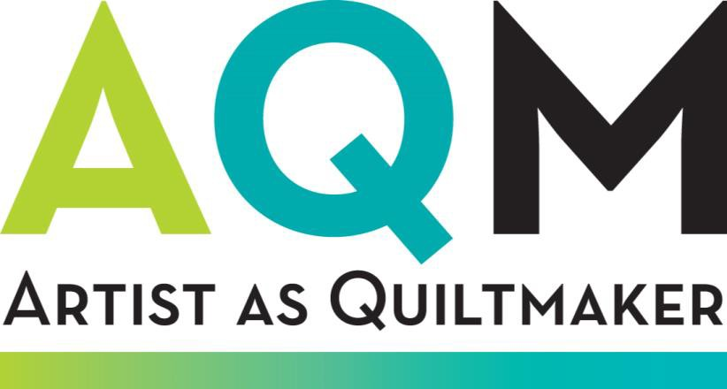

The Artist as Quiltmaker is the second-longest-running art-quilt exhibition in the world. FAVA deliberately chooses not to define “quilt,” thereby encouraging both established and emerging artists to submit innovative artwork, pushing boundaries and challenging expectations, whether they use traditional or non-traditional
techniques or materials.

Juror Elizabeth Kozlowski is an independent curator and editor for the Surface Design Association’s quarterly journal, Surface Design Journal. Her current exhibition project, Craft as Social Practice, will debut at the Florida State University Museum of Fine Arts, Tallahassee, in 2019. She served as curator at Houston Center for Contemporary Craft in 2014; as Windgate Curatorial Fellow at Arizona State University Art Museum; and as an assistant preparator for Crystal Bridges Museum of American Art in 2011. Kozlowski has organized several national traveling exhibitions, including The WildLIFE Project with Wendy Maruyama and Crafting a Continuum: Rethinking Contemporary Craft with the Arizona State University Art Museum.

Kozlowski has a M.A. with honors in museum studies from Arizona State University and a B.F.A. in studio art from Florida Atlantic University, Boca Raton. She is a doctoral candidate in cultural anthropology at Tulane University, New Orleans.

Coordinator
Ruta Marino, Artist and curator aqm.fava@gmail.com

Entry deadline
Sunday, December 1, 2019, midnight (MST)
(no late entries) Entry fee: $40 Cash prizes

Full-color catalog
Calendar
June 1, 2019 Online entry opens
December 1, 2019 Entry deadline, midnight (MST) January 15, 2020 Notification of jury results April 21-24, 2020 Artwork due at FAVA
May 16, 2020 Opening reception
July 26, 2020 Exhibition closes at 5:00 pm August 15, 2020 Return of unsold artwork

About FAVA
Founded in 1979, FAVA is an independent not-for-profit organization in Oberlin, Ohio, dedicated to enhancing public appreciation of and participation in the visual arts through exhibitions and related educational and community activities.
FAVA presents a full season of invitational exhibits, regional and national juried shows, an annual members’ show, and art classes for adults and children. Exhibitions are free and open to the public.

Gallery hours
Tuesday – Saturday 11 am – 5 pm; Sunday 1 – 5 pm

Eligibility
  - Artists living in the U.S. or Canada may submit up to three entries.
  - Innovative two- and three-dimensional quilts are eligible.
  - Work must be completed in 2018 or 2019.
  - Collaborative works are eligible. Artists submitting both collaborative and individual works must apply separately.
- Artwork must be an original design/concept and not created in a class or workshop. Student work is acceptable if created outside the classroom and without an instructor’s guidance.
- Maximum height or width is 108”.

Online entry
  - $40.00, payable during online entry to www.callforentry.org.
  - A total of three separate works may be entered.
  - Entry deadline: Sunday, December 1, 2019, midnight (MST)

Images
  - Jurying will be from digital images only. Image quality is critical. The full image should be on a neutral background with all outside edges of the work visible. Color must represent the work accurately.
  - Two-dimensional entries should have two images: one overall image and one detail.
  - Three-dimensional entries should have three images: one overall image, one detail and one additional full-image view.
  - For image names include initials only, not your full name.
    - Example: for an entry by Jane Doe called Seeds of Hope, the image name would be JD_Seeds.jpg

Image size
  - File format: JPEG or JPG only
  - File dimensions: 1200 pixels or greater on the longest side. Anything larger than 1200 px will be resized to fit the limitations.
  - File size: under 5 MB. Larger files will not upload to the online website.

Jurying
  - Jurying will be from digital images.
  - Work differing significantly from that represented in the digital image will be disqualified and returned to the artist.

Notification
  - Artists will be notified of jury results by email or phone by January 15, 2020.

Catalog
  - A full-color exhibition catalog will be published.
  - Exhibitors will receive a complimentary copy of the catalog.

Delivery of accepted work
  - Round-trip transit insurance and shipping costs to Oberlin are the responsibility of the

artist. A prepaid FedEx or UPS shipping label or account number is required for return shipping. Free FedEx and UPS accounts can be created through the shippers’ websites.
  - All packing materials, including a sturdy container and packing instructions, must be provided for return shipping.
  - Accepted work must arrive at FAVA between April 21 and April 24, 2020.
  - Delivery address: FAVA, 39 S. Main St., Oberlin, Ohio 44074. 440.774.7158.

Sales
  - FAVA will retain a 30 percent commission on all sales.
  - Payment for quilts sold will be sent to the artists by September 30, 2020.

Liability
  - FAVA will insure the work for 70 percent of its fair market value while the work is under its care and reserves the right to limit the amount of insurance coverage on a particular work.
  - Documentation of value will be required in the event of damage or loss.

When ready to submit your entry or entries, register with www.callforentry.org or log in to an existing account:
  - Last name, First name
  - Address, City, Zip code
  - Day phone, Evening phone, Email

Create a portfolio of images in www.callforentry.org:
  - Upload JPGS for your entry or entries.
  - Do not include your name in the JPG names; use only your initials and brief title.
  - Upload one overall image and one detail image for each 2D work.
  - Upload one overall image, a different view of the overall image and one detail image for each 3D work.

Submit your entry or entries to the call “The Artist as Quiltmaker XIX”:
  - Artwork Title
  - Medium: (60 character limit)
  - Size (in inches): Height Width Depth (enter Depth as zero for 2D work)
  - Price/Value
  - Year completed: (must be either 2018 or 2019)
  - Primary discipline: (drop down list may be expanded to include quilt)
  - Description (300 character limit). Use for techniques.
  - First time AQM entrant: Yes or No
  - Previous AQM exhibitor: Yes or No
  - Materials: Use this field if the 60 character limit in the Medium field did not give enough space to include all materials.
  - Techniques: List specific techniques used here if the 300 character limit in the Description field was not adequate. Include quilter’s name here if not the artist.

- Statement: A 50-100 word statement about this specific piece, written in the first person. Do not write in the third person, as if for a press release, i.e. do not include your name in the statement.
- Photo credit: Photographer’s name if entries not photographed by the artist.

The Artist as Quiltmaker XIX Contract
  - Submission to The Artist as Quiltmaker XIX requires that the artwork entered will be
available for the exhibition if accepted and that the artist understands that all work must remain at FAVA for the duration of the exhibition.
  - By submitting work to The Artist as Quiltmaker XIX at www.callforentry.org the artist
agrees to have their artwork and themselves photographed and to permit images, details of images, and all or part of the artist’s statement/bio to be used in all media support and outreach materials.
  - High-resolution (300DPI), 8x10-inch digital jpgs of the accepted artwork’s overall image and detail must be emailed to the coordinator at aqm.fava@gmail.com upon receipt of the artist’s contract.
  - Accepted artwork must be ready for installation, including appropriate hanging devices. All rods or special hooks as well as installation instructions must be included with the artwork.

Questions?

Contact the online website’s tech support staff at cafe@westaf.org when:
  - you have questions about uploading media or about your portfolio of images.
  - you encounter an error message on the website that is preventing an action.
  - the callforentry.org website cannot be accessed.
  - you need help navigating the website menu or in understanding the site features.
  - Note: the website office is located in Colorado, which follows Mountain Standard Time.

Contact the AQM coordinator at aqm.fava@gmail.com when you have questions about:
  - eligibility or submission rules.
  - the history and mission of FAVA, the organization sponsoring the call.
  - how to obtain entry fee refunds.
  - the results of the jury review and timeline for notifications.
  - how to edit your application after you have submitted it.

Submit your entries at www.callforentry.org The call will be titled: The Artist as Quiltmaker XIX Entry deadline: December 1, 2019, midnight (MST) (no late entries accepted)
Firelands Association for the Visual Arts at the Oberlin Center for the Arts 39 S. Main Street, Oberlin, Ohio 44074 440.774.7158

